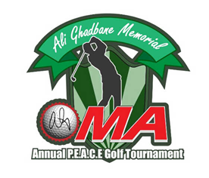

Fred Ghadban & Theo Tannis (Committee Co-Chair’s)
3 Hatton Place Nepean, Ontario, K2G 3E1
Home 613-226-2437 Cell 613-859-0083

Dear Sponsor:
The OMA P.E.A.C.E. Charity Golf tournament is proud to announce that we will be hosting our 13th annual Charity Golf Tournament on Monday July 22nd, 2019 at Grey Hawk Golf Club. This year’s tournament will be in memory of the late Hajj Ali Ghadbane, who was an avid golfer and an active member of the Ottawa Muslim Association (OMA).

Proceeds raised from this year's tournament will be donated to The Ottawa Hospital
Foundation and various OMA projects. The funds raised will be spent locally to support Ottawa Hospital cancer patients as well as to finance projects at the Ottawa Mosque. We are hopeful that your tournament sponsorship will greatly increase the money directed towards both of these well deserving causes.

We recognize that local fund raising is a team effort. We would genuinely appreciate your corporate donation as well as participation in this year’s tournament. Your company can participate at various sponsorship levels, namely: corporate donation/participation, individual donation, golf hole sponsorship or Program WEB recognition. Your corporation will receive recognition at the tournament and on the tournament website.

If you require additional information concerning donations or team registration please contact any one of the following team members.

Fred Ghadban 613-226-2437 Co-Chair
Theo Tannis 613-720-5050 Co-Chair

Or via email at info@ottawacharitygolf.org

On behalf of the Committee and organizers we would like to thank you, in advance, for your kind support and look forward to hearing from you.

Sincerely,

Fred Ghadban
Theo Tannis
Tournament Co-Chair’s

