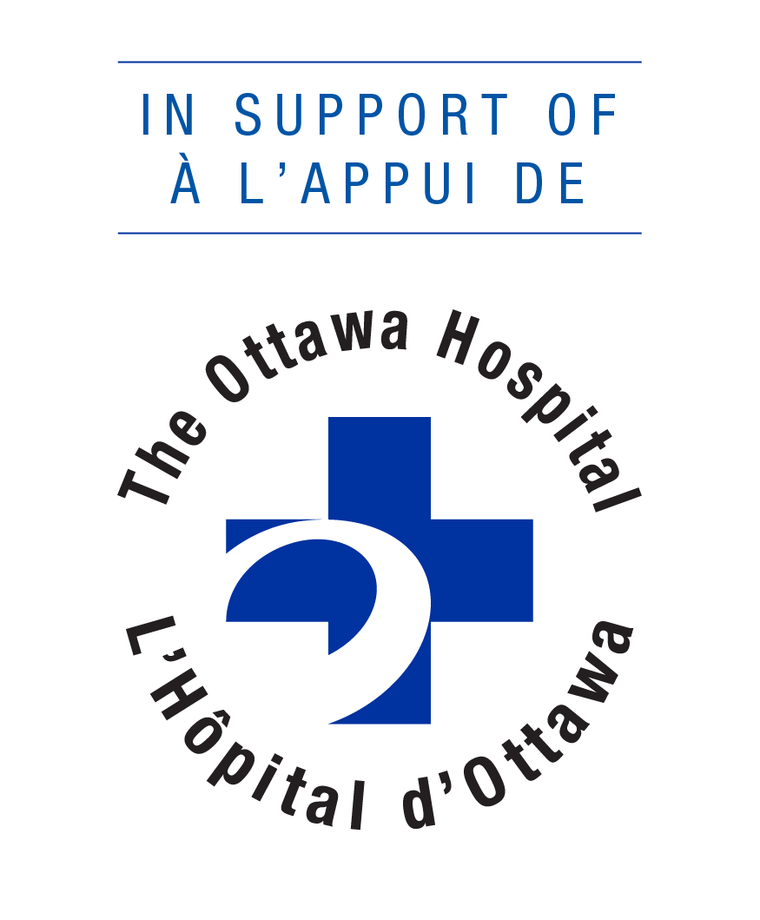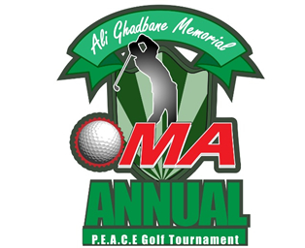
Fred Ghadban & Theo Tannis (Committee Co-Chair’s)
3 Hatton Place Nepean, Ontario, K2G 3E1
Home 613-226-2437 Cell 613-859-0083
Dear Sponsor:
The OMA P.E.A.C.E. Charity Golf tournament is proud to announce that we will be hosting our 13th Annual Charity Golf Tournament on Monday July 22nd, 2019 at Grey Hawk Golf Club. This year’s tournament will be in memory of the late Hajj Ali Ghadbane, who was an avid golfer a charitable man and an active member of the community.

Proceeds raised from this year's tournament will be donated to The Ottawa Hospital
Foundation OMA PEACE endowment fund to fund projects at the Ottawa Hospital – General Campus Cancer Care 5E unit. The funds raised will be spent locally to support Ottawa cancer patients. We are hopeful that your tournament sponsorship will greatly increase the money directed toward this well deserving causes.

We recognize that local fund raising is a team effort. We would genuinely appreciate your corporate donation as well as participation in this year’s tournament. Your company can participate at various sponsorship levels, namely: corporate donation/participation, individual donation, golf hole sponsorship or Program WEB recognition. Your corporation will receive recognition at the tournament and on the tournament website.

If you require additional information concerning donations or team registration please contact any one of the following team members.

Fred Ghadban 613-226-2437 Co-Chair
Theo Tannis 613-796-6972 Co-Chair
Or via email at info@ottawacharitygolf.org

On behalf of the Committee and organizers we would like to thank you, in advance, for your kind support and look forward to hearing from you.

Sincerely,

Fred Ghadban Tournament Co-Chair’s
Theo Tannis Tournament Co-Chair’s

